Brett Vogelsang

CSC 380

2/1/21

Conceptual and Logical Dimensional Data Models

Conceptual Data Model

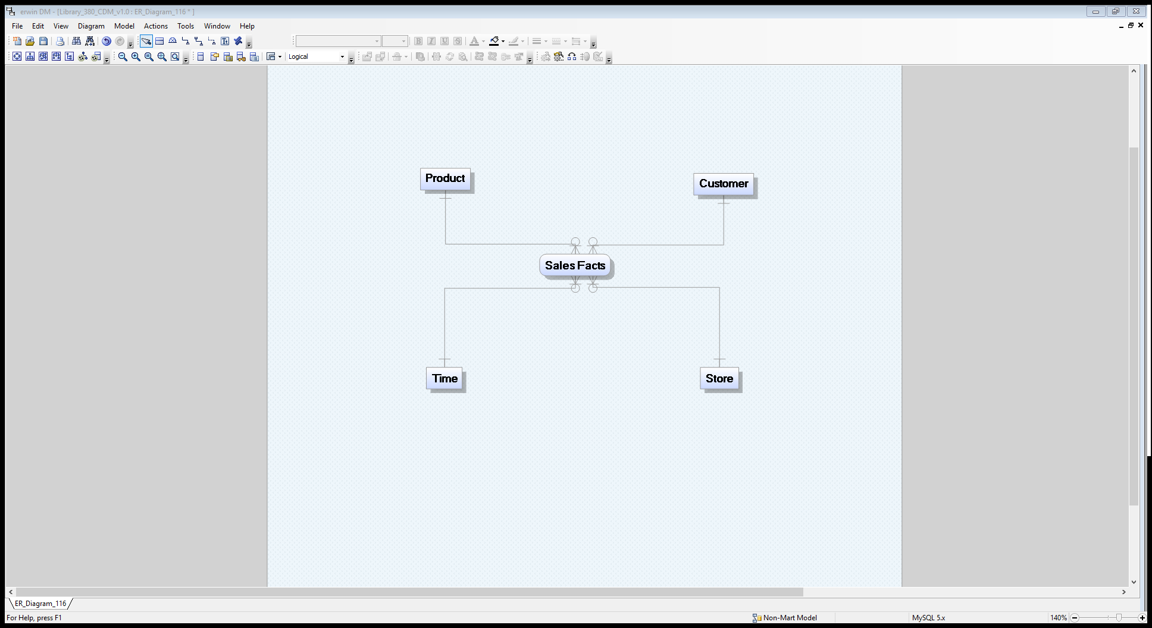

Logical Data Model

